**Ideation Phase**

**Brainstorm & Idea Prioritization Template**

|  |  |
| --- | --- |
| **Date** | 16th june, 2025 |
| **Team ID** | LTVIP2025TMID36145 |
| **Project Name** | TrafficTelligence : Advanced Traffic Volume Estimation with Machine Learning |
| **Maximum Marks** | 4 Marks |

Brainstorming ideas is a creative process where a group generates a list of

potential solutions, suggestions, or concepts for a specific problem or project.

Voting in brainstorming involves participants selecting and prioritizing their

favourite or most promising ideas from the list to determine which ones should

be pursued further.

**Brainstorming for “TrafficTelligence : Advanced Traffic Volume Estimation with Machine Learning”:**

The objective of this brainstorming session is to generate creative and practical ideas to address the issue of Traffic Volume estimation effectively. We aim to help people able to plan their days better as they will have a better idea on how the traffic is going to be. It will also help traffic authorities be able to regulate traffic better.

The brainstorming session will include a diverse group of stakeholders, including public people, Traffic authorities, educators, community leaders, and technology enthusiasts. This diversity will ensure a wide range of perspectives and ideas.

**Step-1 : Team Gathering, Collaboration and Select the Problem Statement**

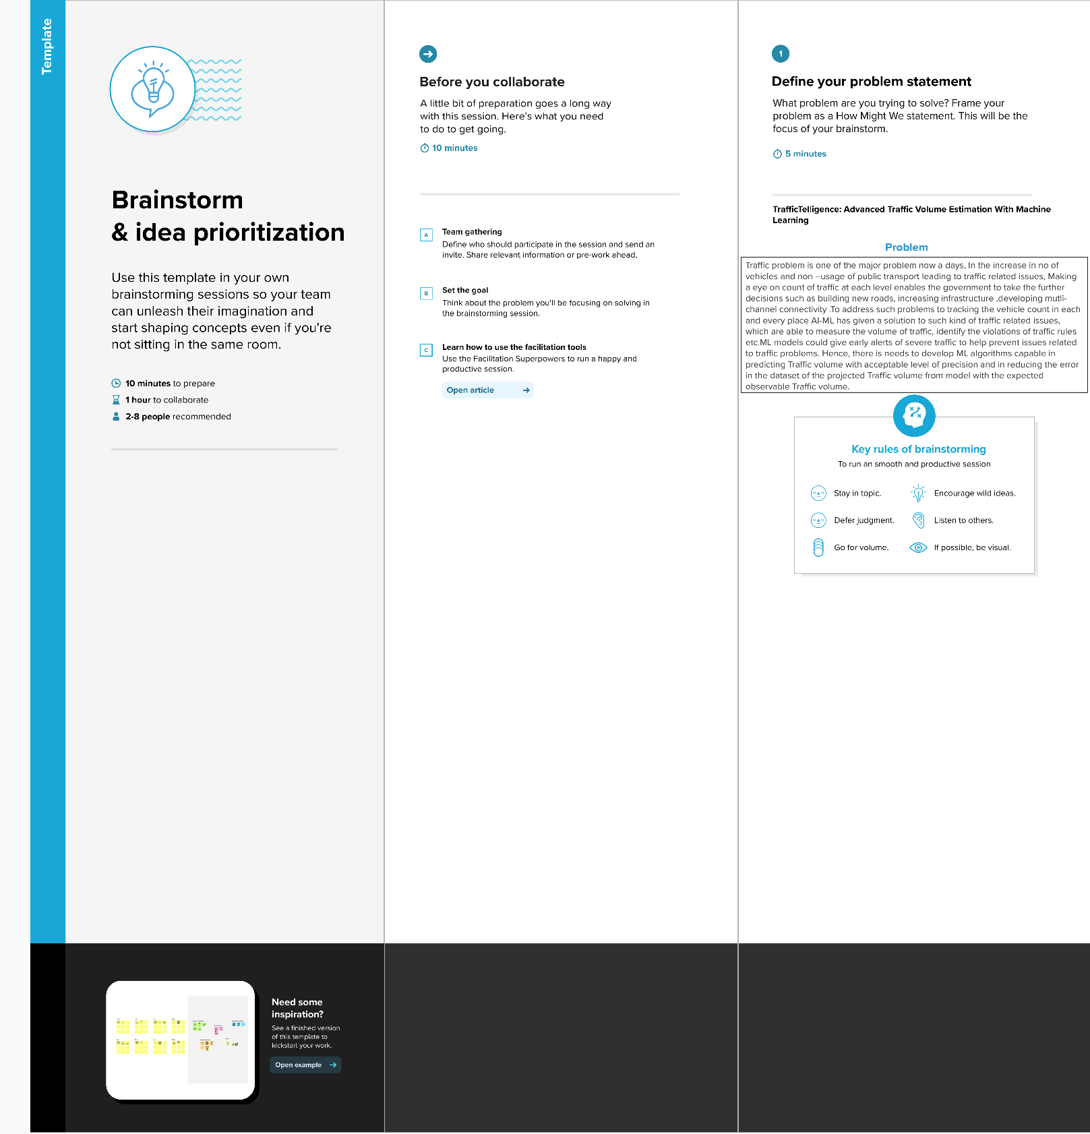

**Step-2: Brainstorm, Idea Listing and grouping**

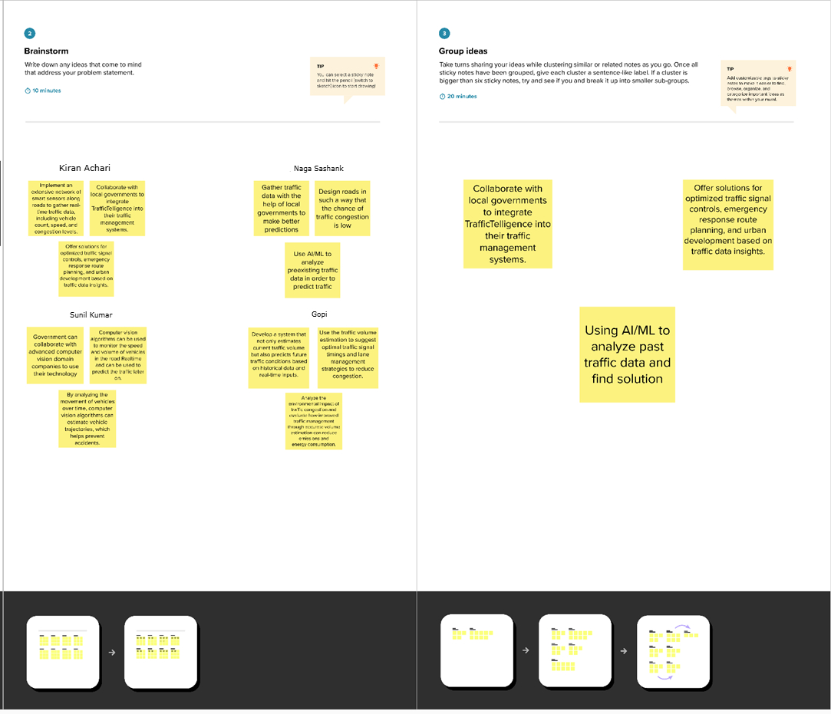

**Step-3: Idea Prioritization**

Idea prioritization is the process of ranking or assessing ideas based on specific criteria such as feasibility, impact, cost, or strategic importance to determine which ideas should be implemented or pursued first.

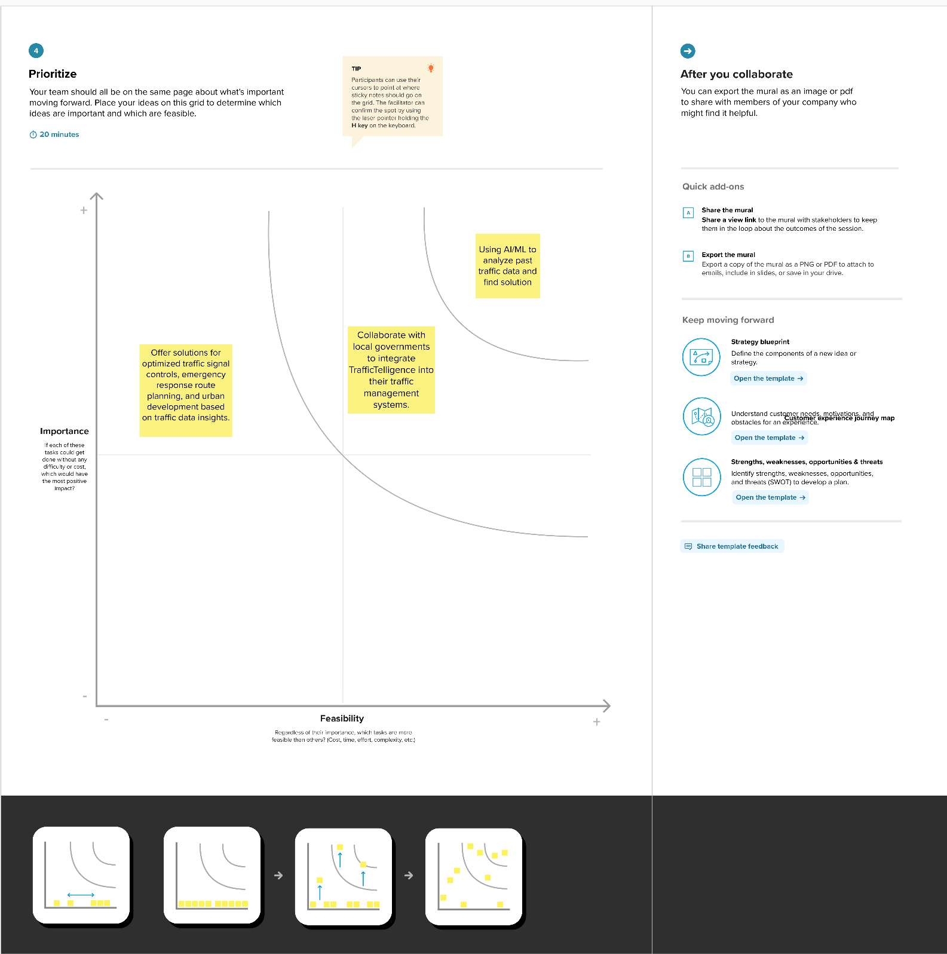

**Here certainly we chose “Using AI/ML to analyze past traffic data and find solution” is:**

Among all of other ideas this was most important to us because, if the model is not accurate enough then the prediction may not be highly accurate. So, this was our most prioritized one.

Then comes our second most important idea such as **“Collaboration with local government to integrate TrafficTelligence into their traffic management systems”**. This was taken as our second because, if we want to give ourself a social responsibility that will be helpful, not only to use but also for others. If we work with other government or organization this might be helpful for a smooth traffic without any problems for Traffic authorities and also for people.

Then comes out our next idea **“Offer solutions for optimized traffic signal controls, emergency response route planning, and urban development based on traffic data insights.”** After fulfilling our main goal, we will scale our ML model not only to predict our main problem but also for extra features such as above-mentioned things. This will give our project more value in all ways.